
BANK MANAGEMENT SYSTEM
Module Based Program
ALI HAMZA {004} | 6/19/25 | Programming Fundamentals

- Project Title:

“BANK MANAGEMENT SYSTEM”

- Comprehensive Overview:

The Bank Management System is a Java-based console application designed to simulate core banking operations, including account management, fund transfers, and transaction tracking. The system supports two distinct user roles:
- Administrators – Have full access to account management functions, including creating, updating, and searching accounts, as well as processing fund transfers and viewing transaction logs.
- Users (Account Holders) – Can access their account details, check balances, and log out.
- Key Features:

- Admin Functions
- Create Account
  - Stores account details (name, age, ID, balance) in accounts.txt and a user-specific file.
- View All Accounts
  - Displays all accounts from accounts.txt.
- Update Account
  - Modifies account details (name, age, balance) by ID.
- Search Account
  - Retrieves account details by ID.
- Transfer Funds
  - Transfers money between accounts and logs transactions in transactions.txt.
- View Transactions
  - Displays all recorded transfers from transactions.txt.
- User Functions

- View Account Details
  - Shows name, age, ID, and balance from the user's file.
- View Balance
  - Displays the account balance for a given ID.
- Logout
  - Returns to the main menu.
3. Code Structure
Classes and Methods
Method | Description
loginAdmin() | Authenticates admin credentials (hardcoded as "Admin"/"Admin1234").
adminMenu() | Displays admin options and routes to respective functions.
userMenu() | Validates user ID and provides access to user functions.
createAccount() | Saves new account data to accounts.txt and a user-specific file.
viewAllAccounts() | Reads and displays all accounts from accounts.txt.
updateAccount() | Modifies account details by ID and updates the file.
searchAccount() | Searches for an account by ID and displays details.
transferFunds() | Handles money transfers between accounts and logs transactions.
viewTransactions() | Prints all transactions from transactions.txt.
viewBalance() | Shows the balance for a specific account ID.
viewAccount() | Displays all details of the logged-in user from their file.
    - Files Used
- accounts.txt
  - Stores all account data in CSV format:
Name,Age,ID,Balance
- transactions.txt
  - Logs fund transfers with timestamps:
Transferred Rs. X from Sender (ID: Y) to Receiver (ID: Z) on [Date]
- [Username].txt
  - User-specific file storing their account details (same format as accounts.txt).
4. Strengths
✔ Modular Design
- Separates admin/user roles and functions clearly.
✔ File-Based Persistence
- Uses text files to store data without a database.
✔ Input Validation
- Handles invalid inputs (e.g., non-numeric IDs) gracefully.
✔ Transaction Logging
- Records transfers with timestamps for auditability.
6. How to Run
- Compile and execute testing.java (Java 8+ required).
- Use these test credentials:
  - Admin: Name = Admin, Password = Admin1234
  - User: Enter a valid ID from accounts.txt.
-----------------------

- SOURCE CODE:

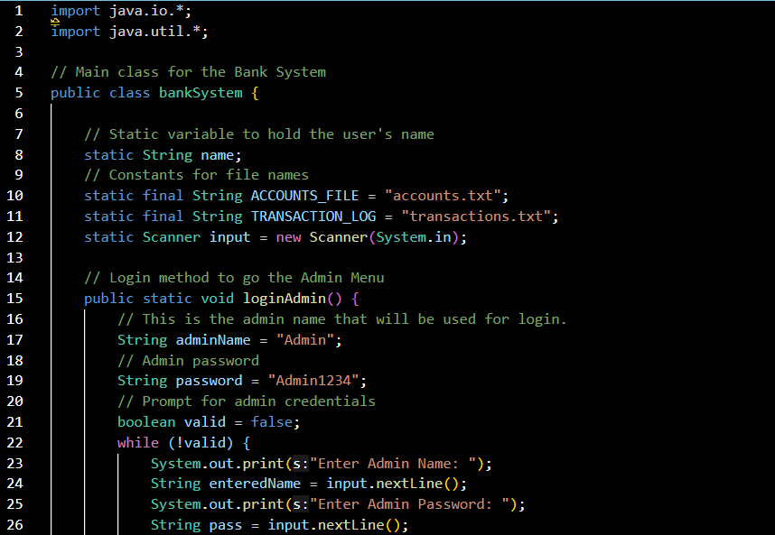
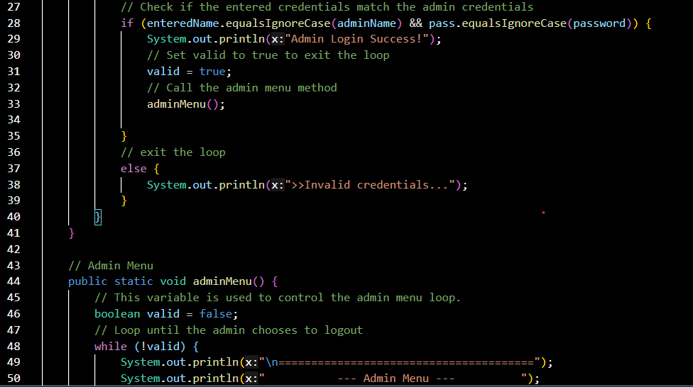
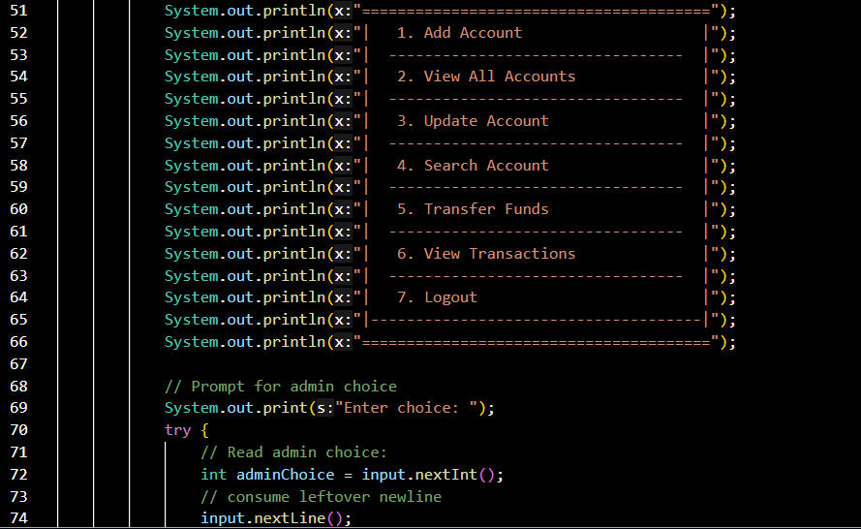

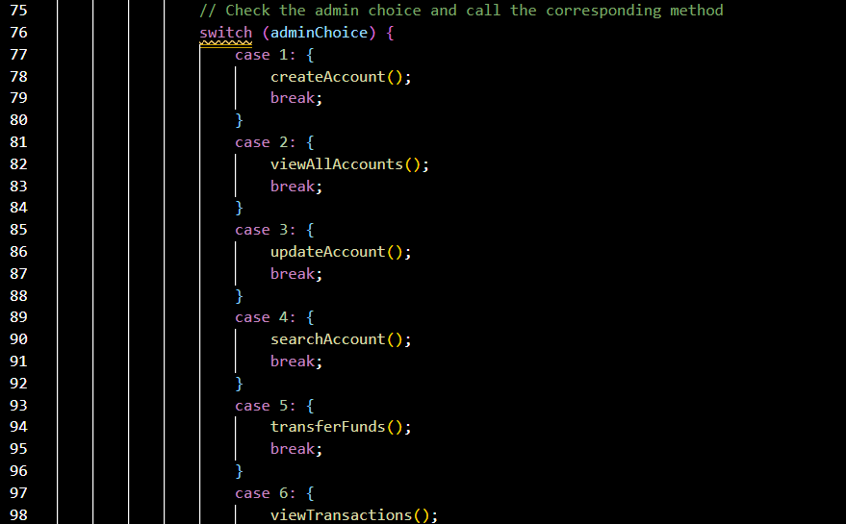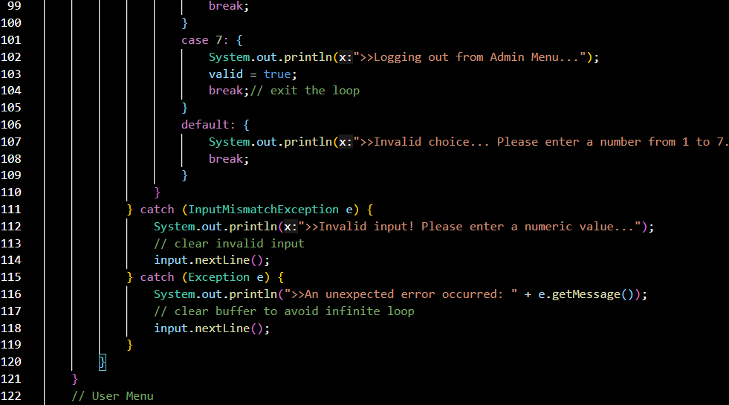
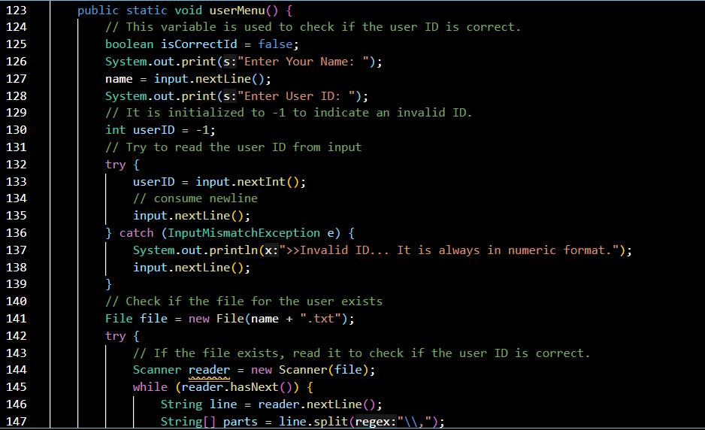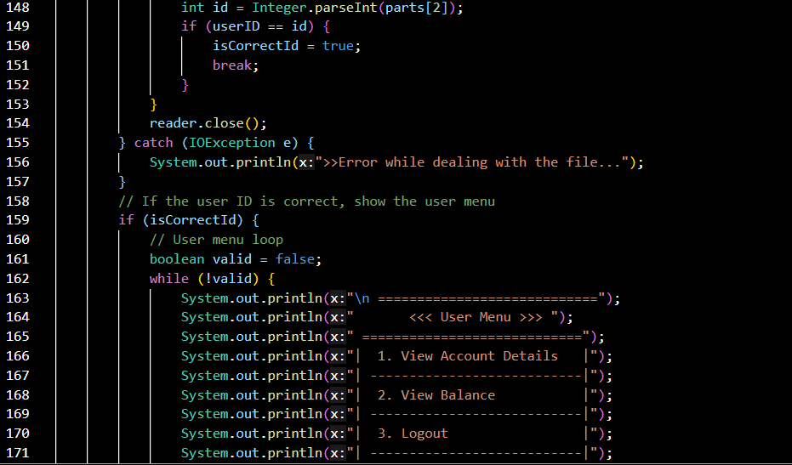

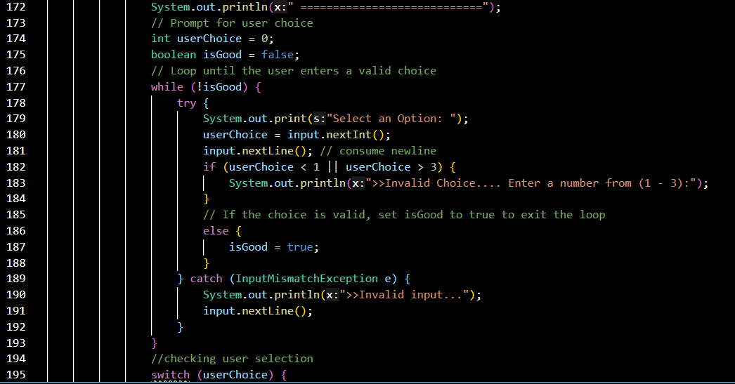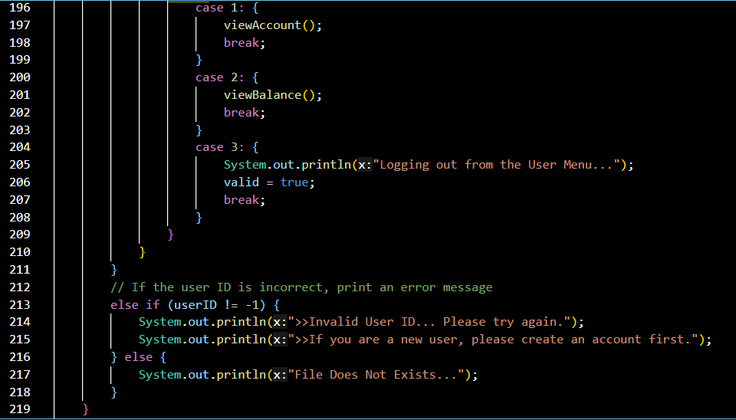

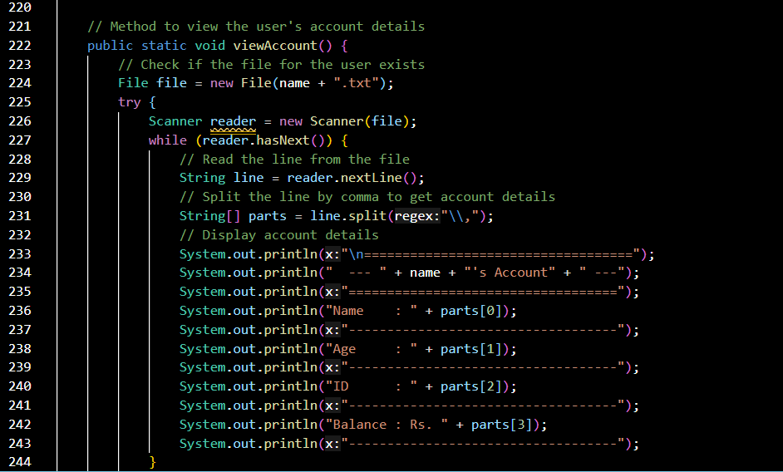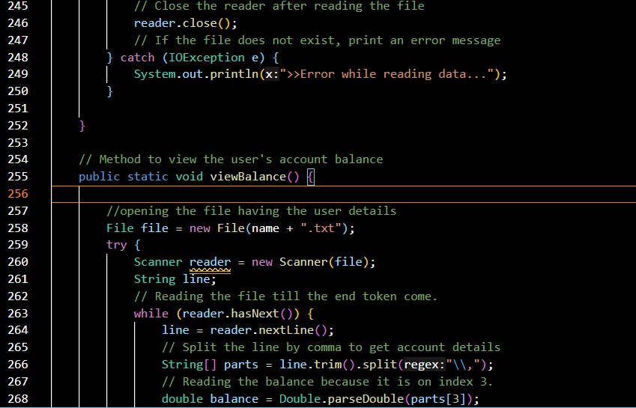
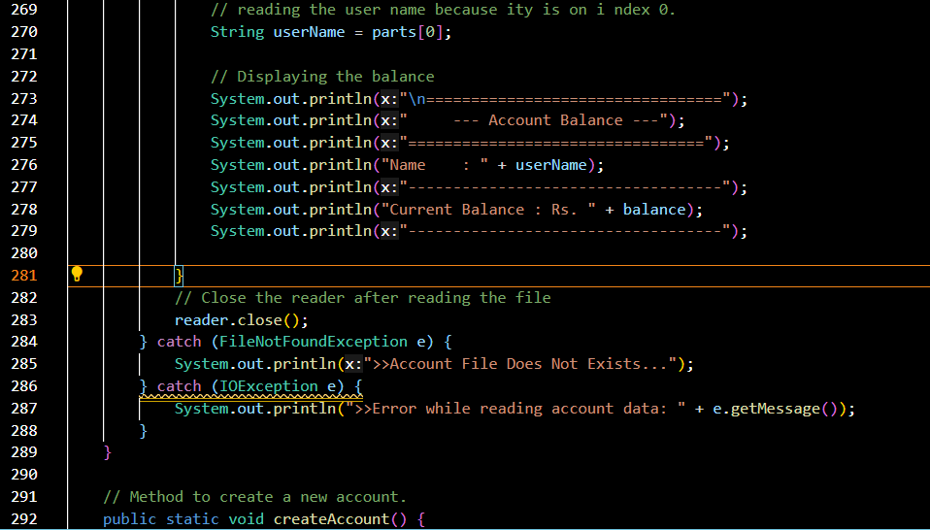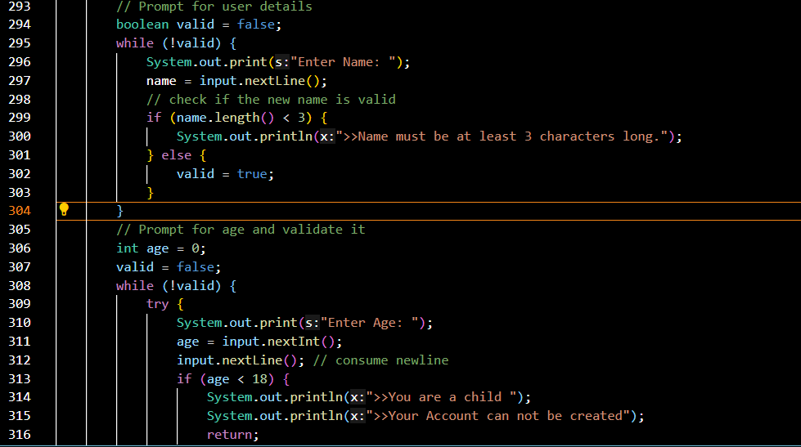
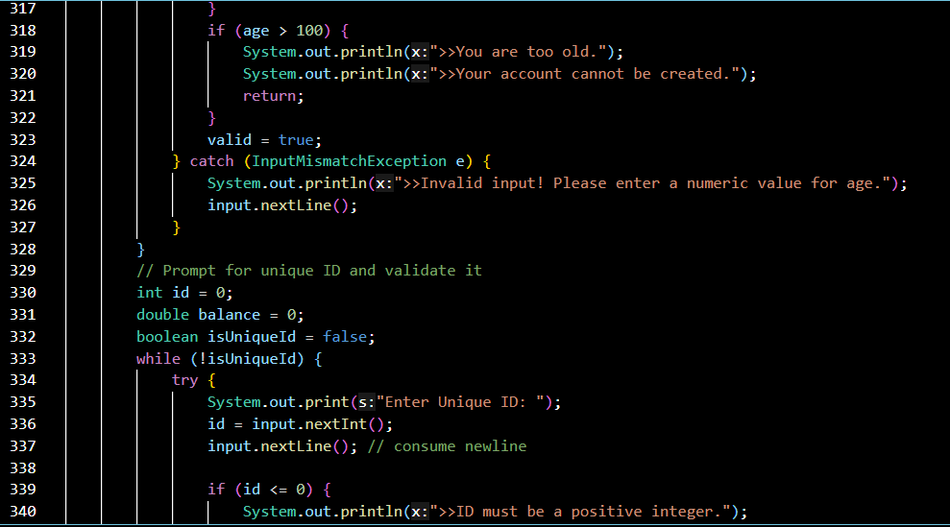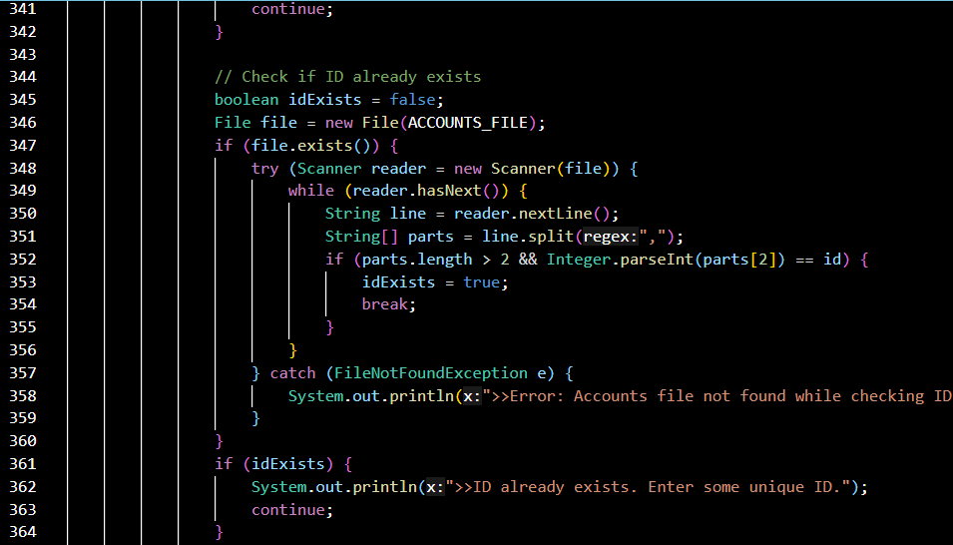

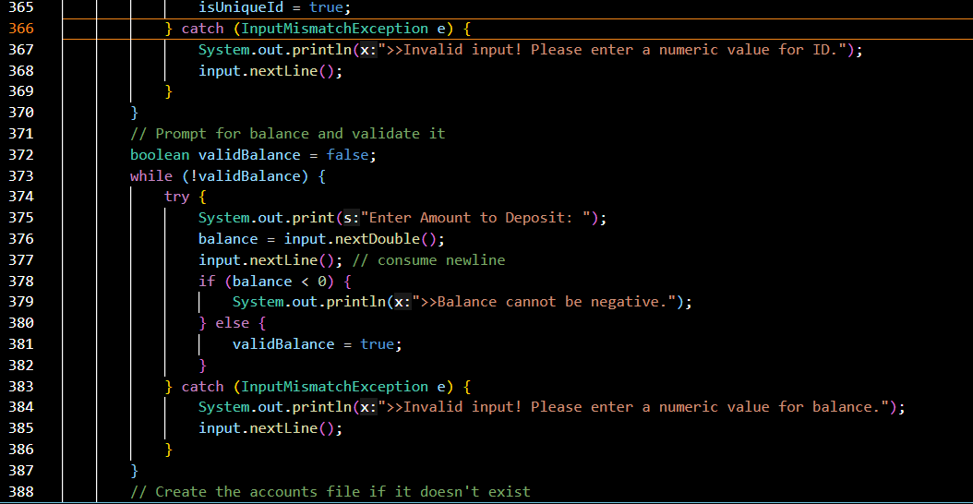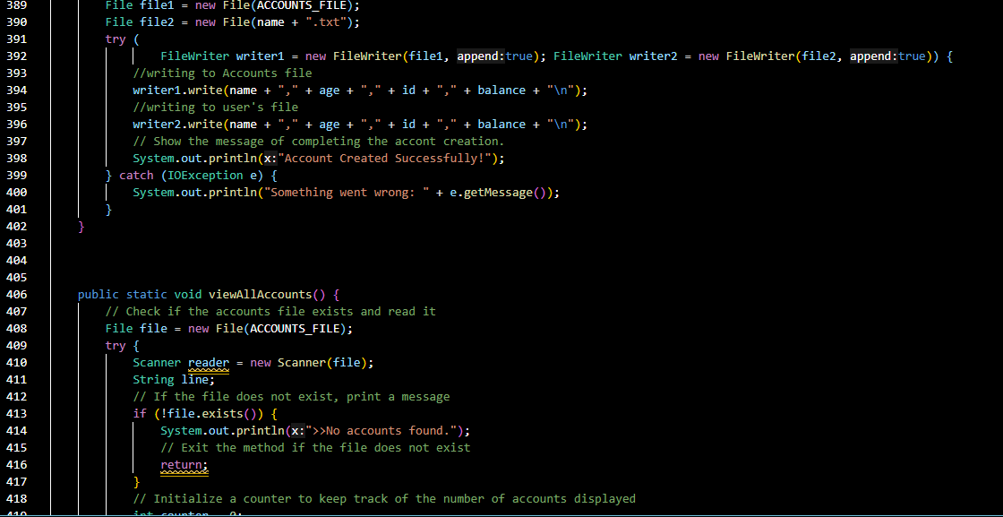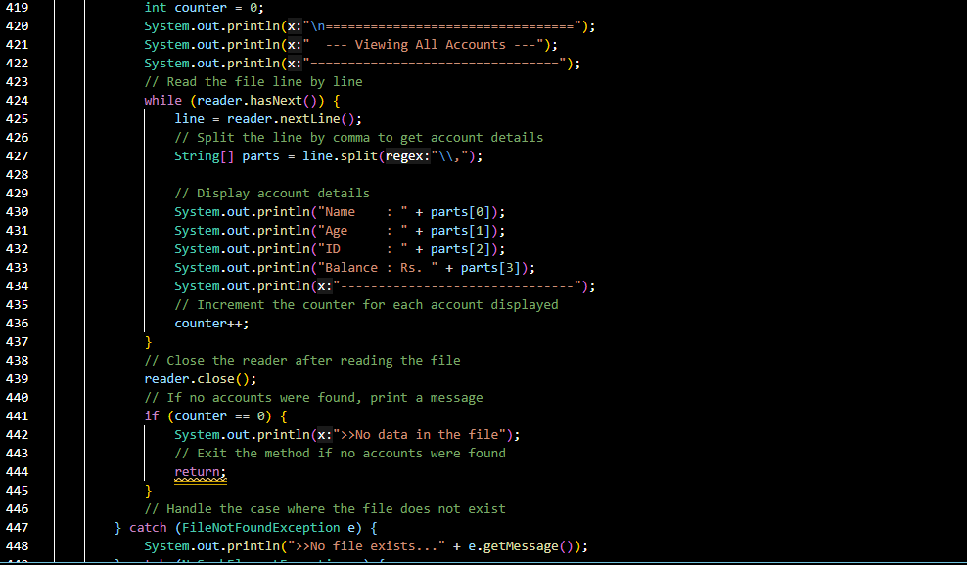
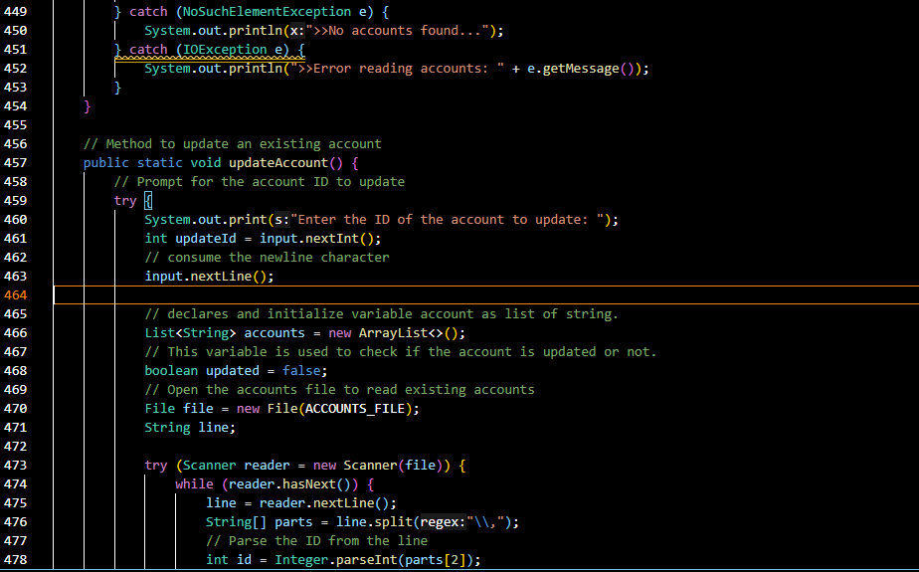
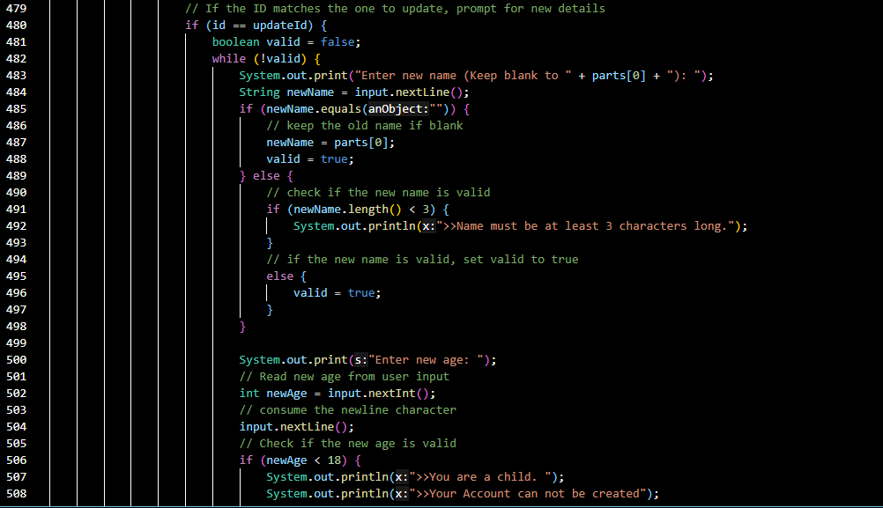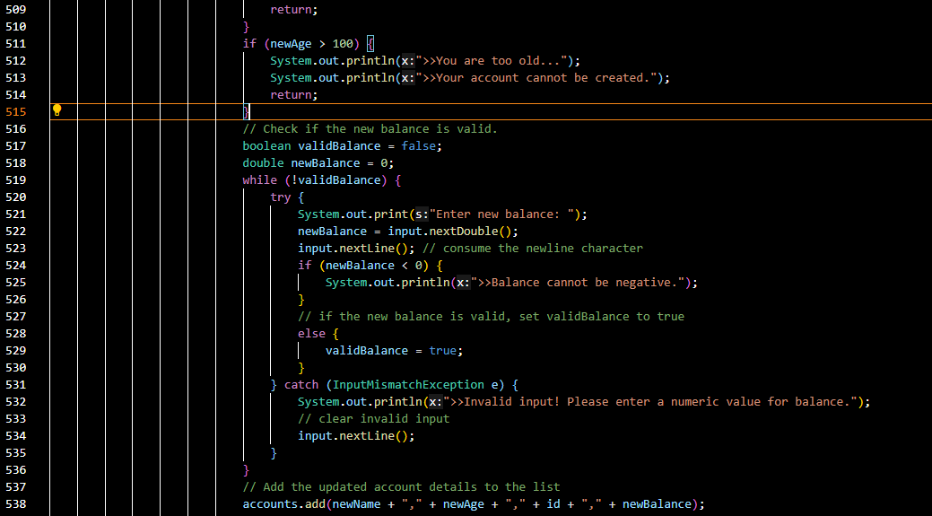
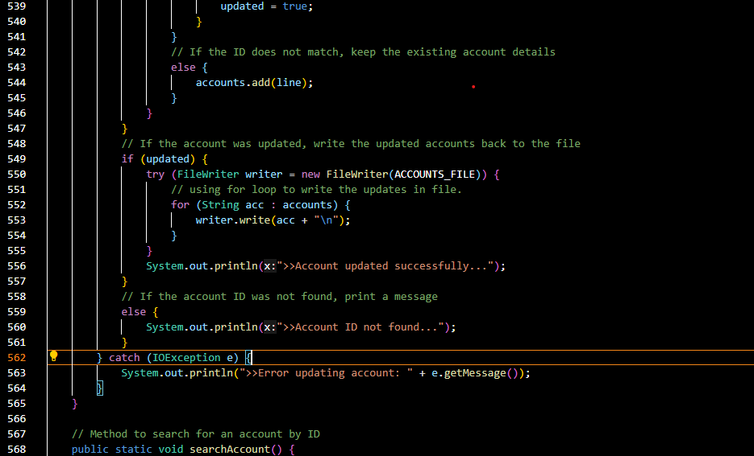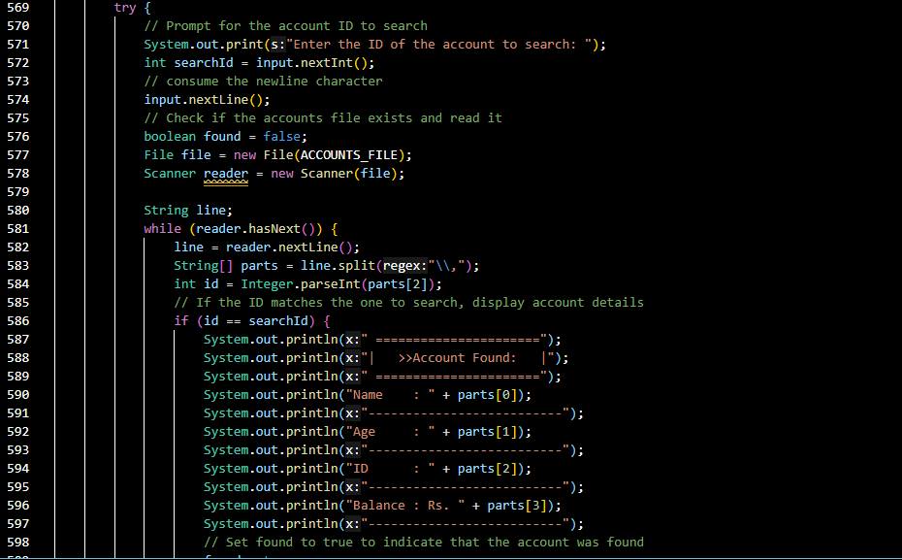
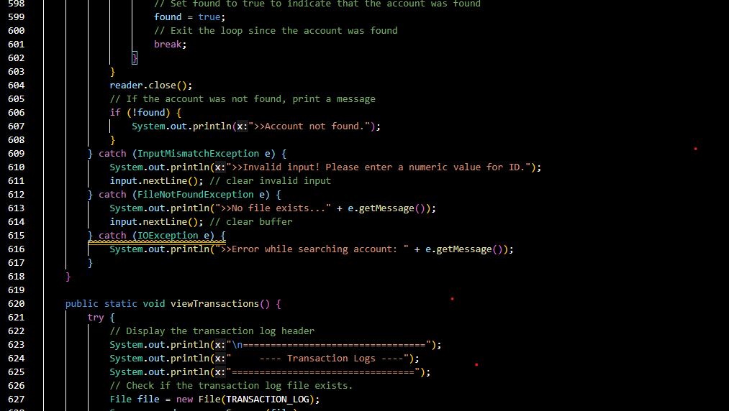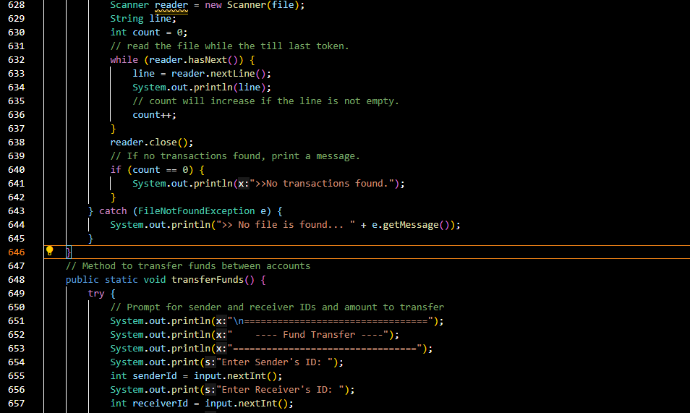
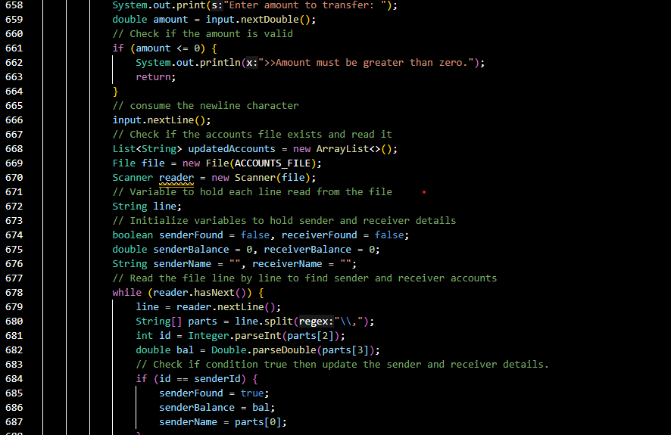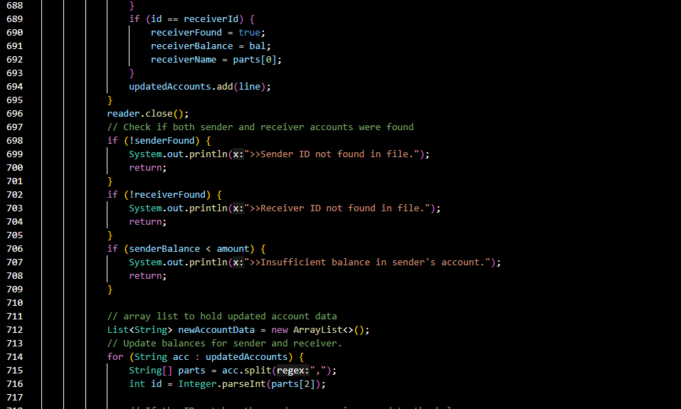
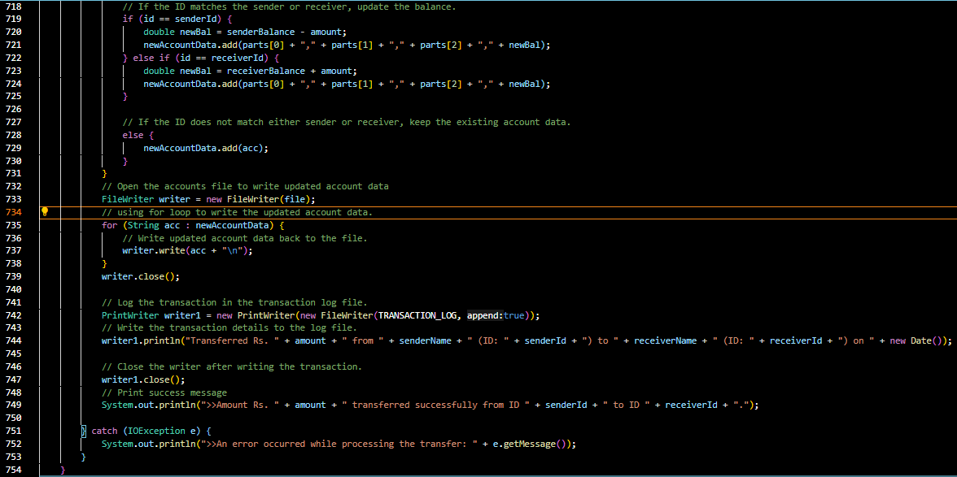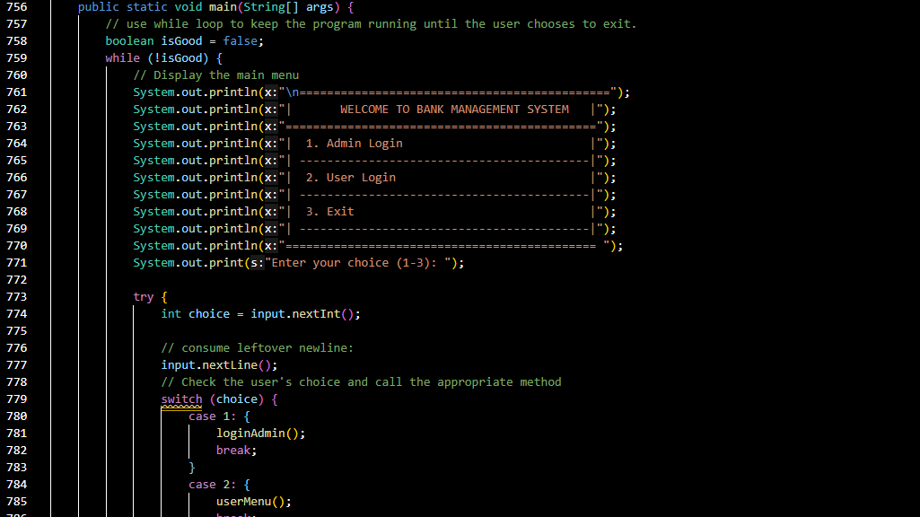
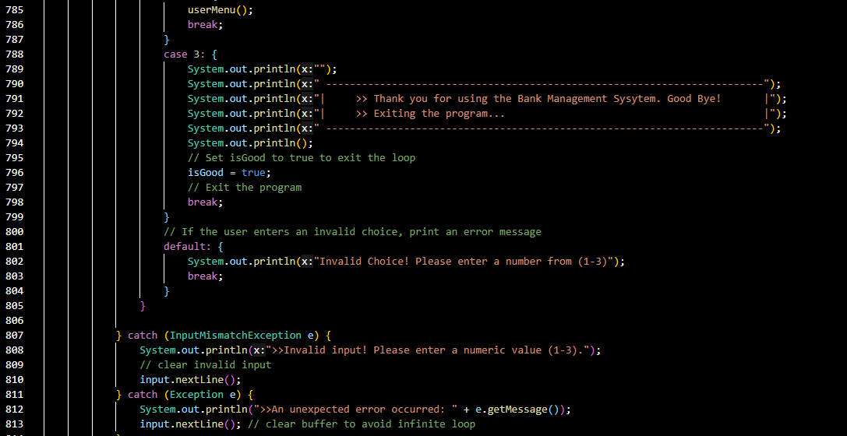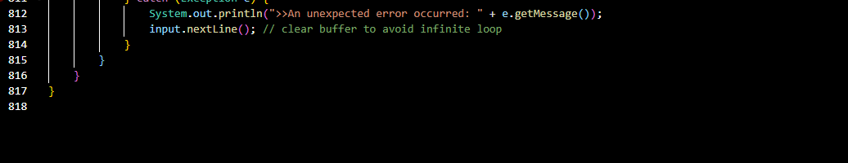

- OUTPUTS :
  - Main Menu:
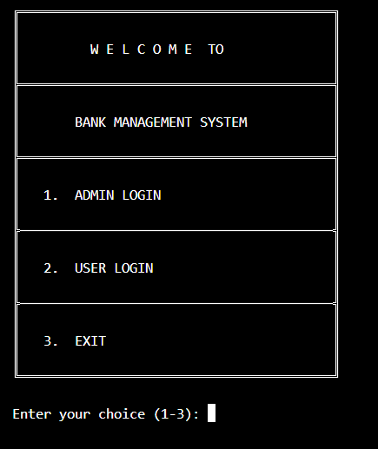

- Admin Portal:
  - Login Section:
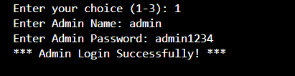

Admin Panel:
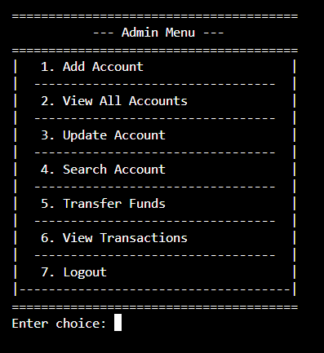
Add Account
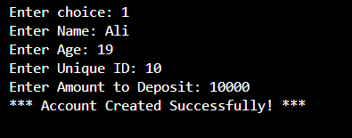

View All Accounts
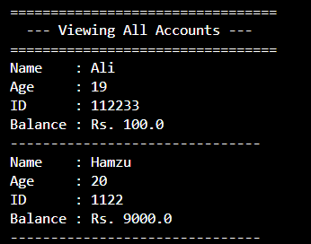

Fund transfer
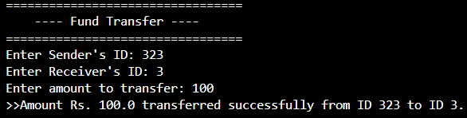

Transaction Log
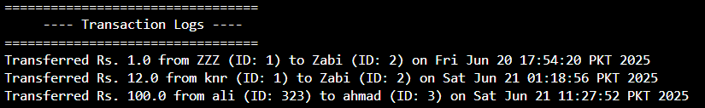

- User Portal:

User Login
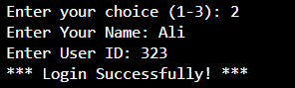

User Menu
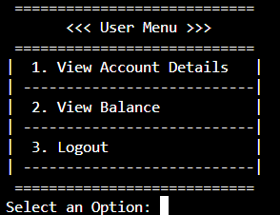

View Account Details
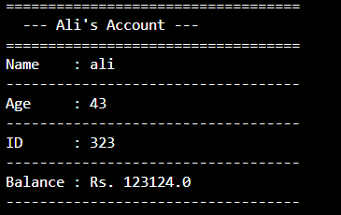

- Exit:

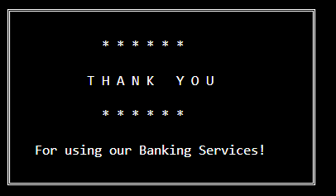

The End

